**INDOOR SPORTS**

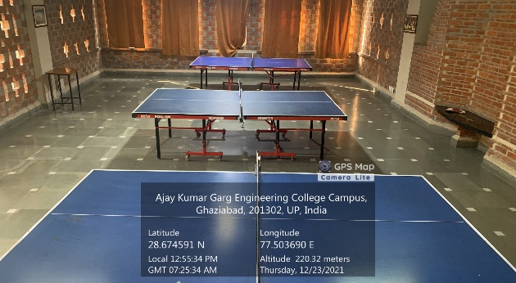

**TABLE TENNIS**

**(BOYS HOSTEL)**

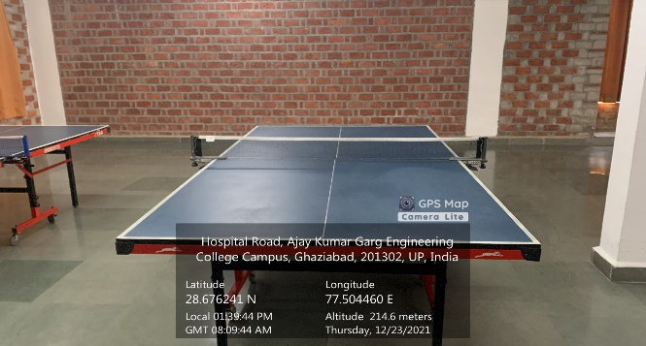

**TABLE TENNIS**

**(GIRLS HOSTEL)**

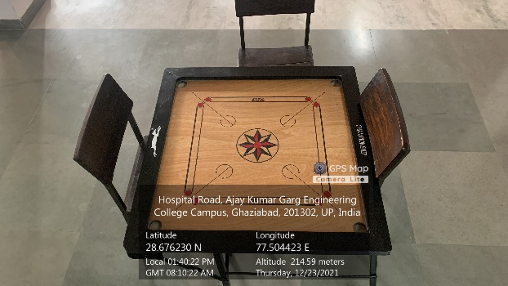

**CARROM BOARD**

**(GIRLS HOSTEL)**

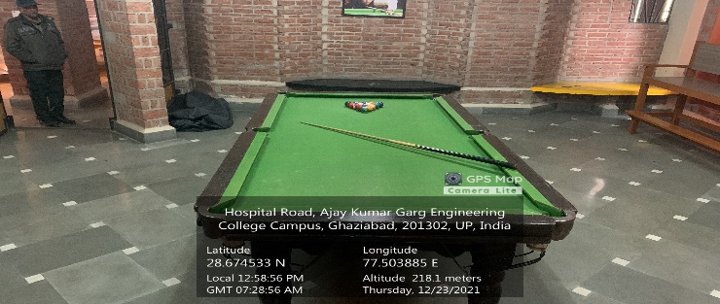

**POOL TABLE**

**(BOYS HOSTEL)**

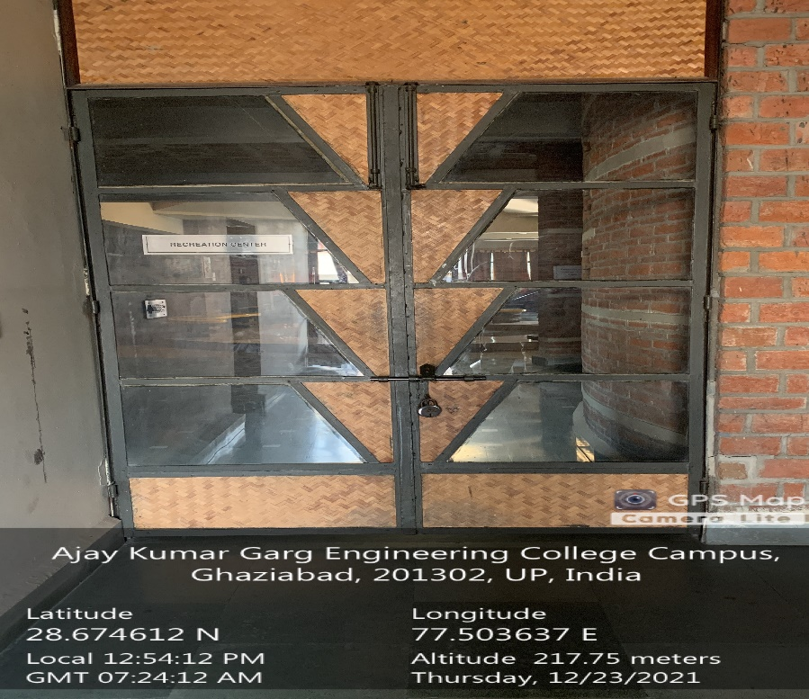

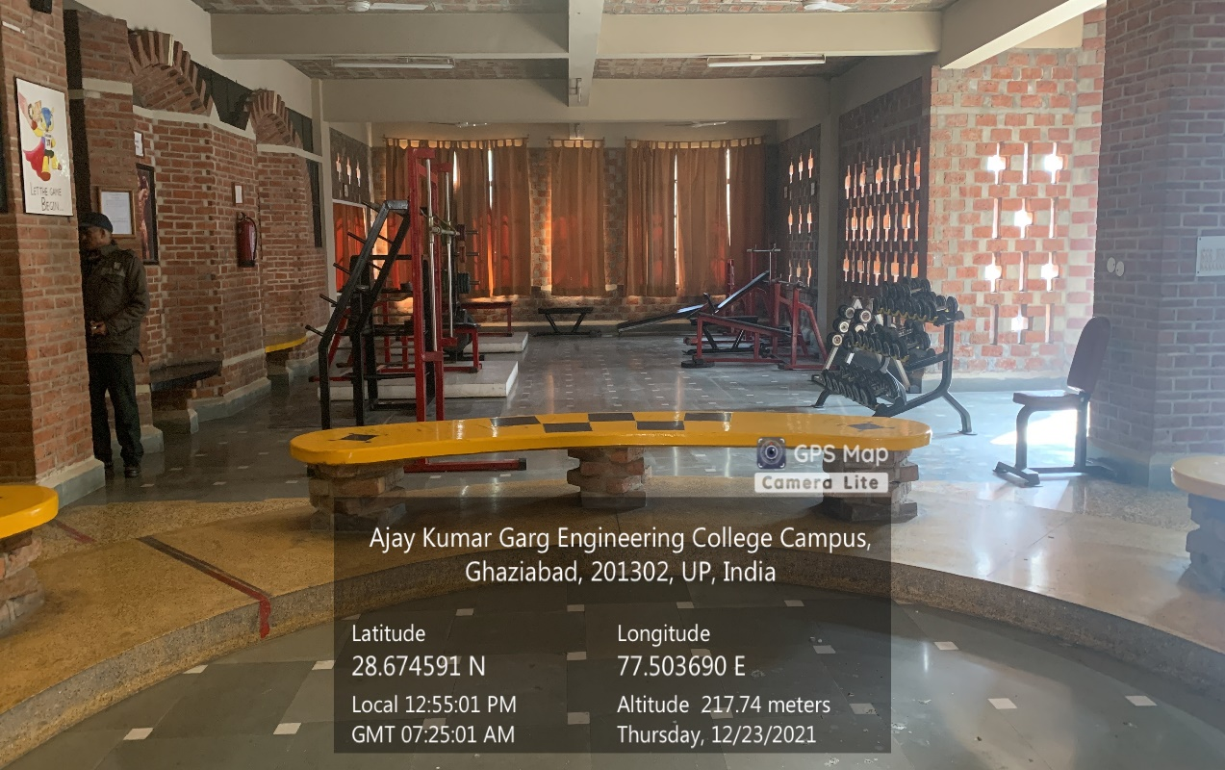

**GYMNASIUM-1**

**(BOYS HOSTEL)**

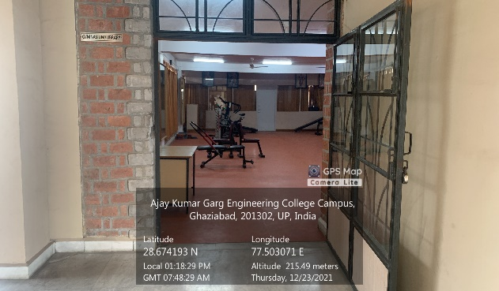

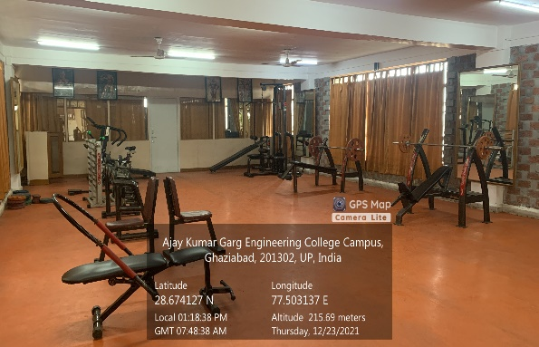

**GYMNASIUM-2**

**(BOYS HOSTEL)**

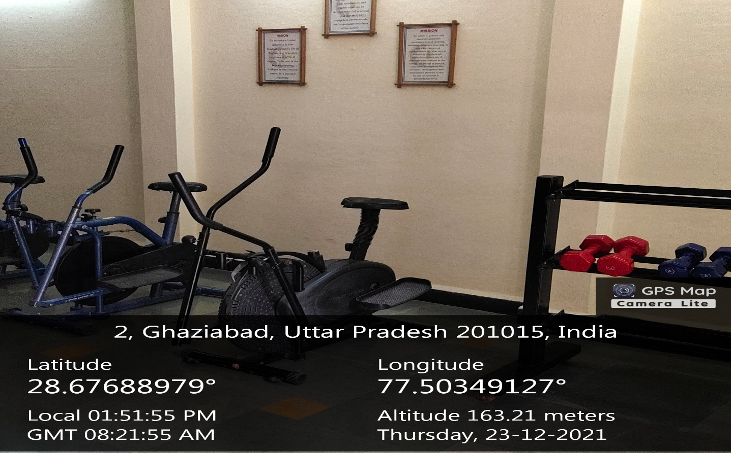

**GYMNASIUM-1**

**(GIRLS HOSTEL)**

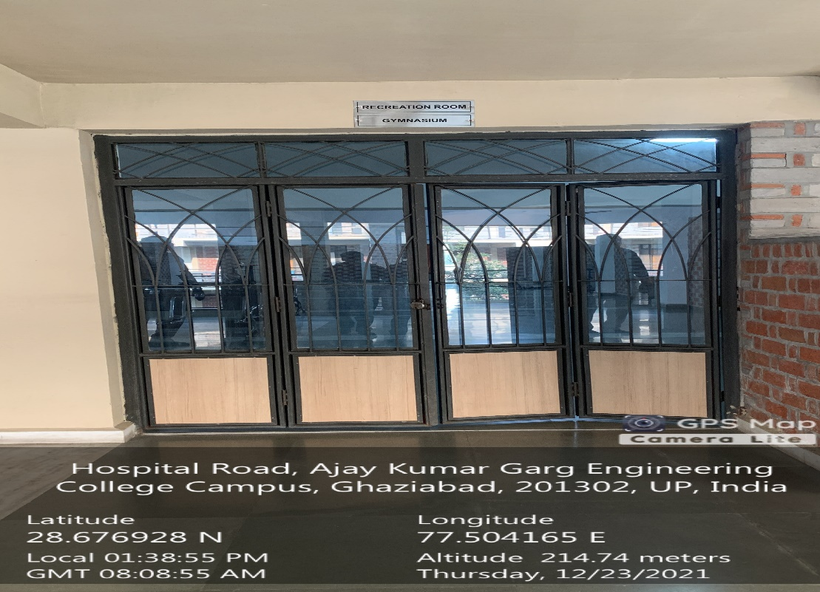

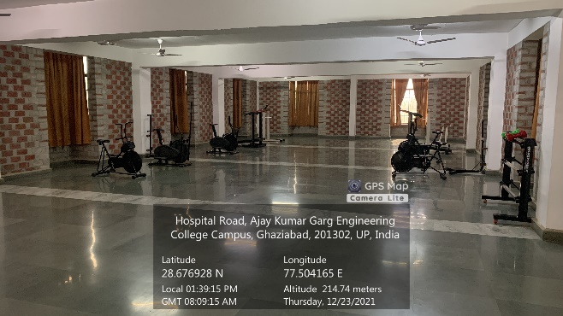

**GYMNASIUM-2**

**(GIRLS HOSTEL)**

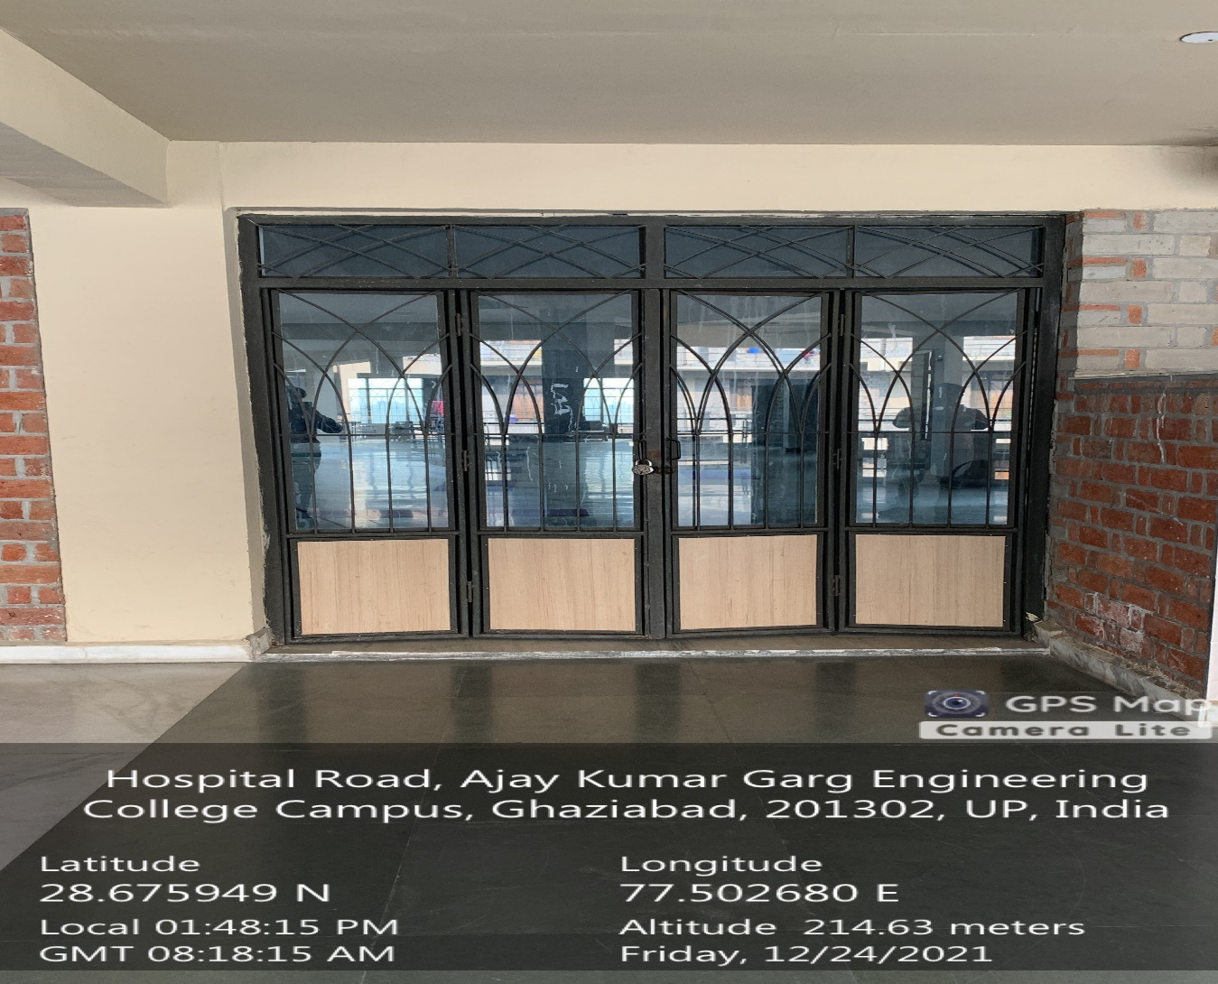

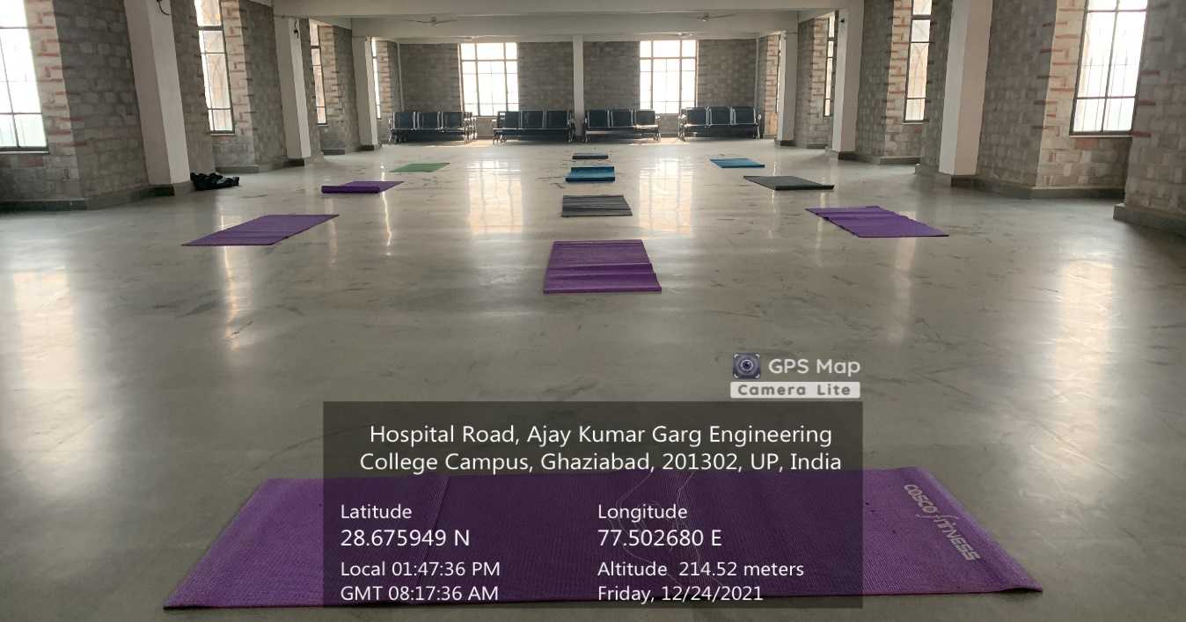

**YOGA ROOM**

**(GIRLS HOSTEL)**

**OUTDOOR SPORTS**

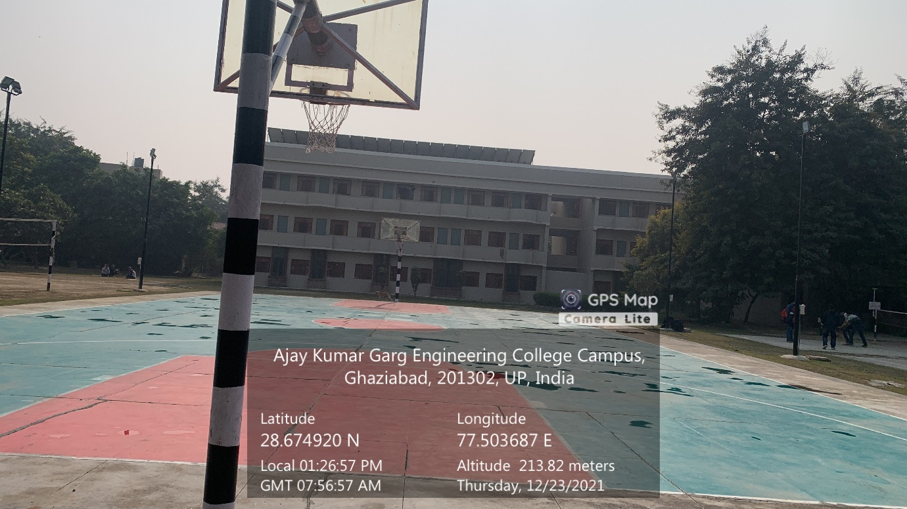

**BASKETBALL COURT**

**(BOYS HOSTEL)**

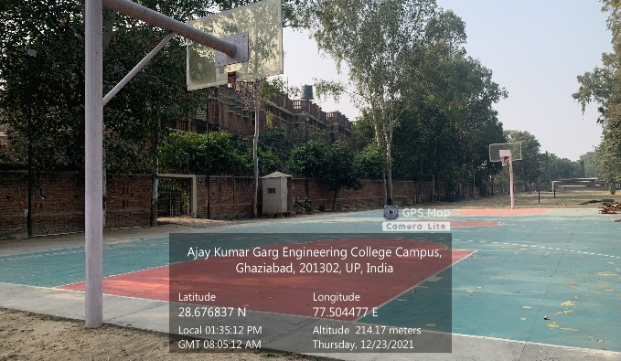

**BASKETBALL COURT**

**(GIRLS HOSTEL)**

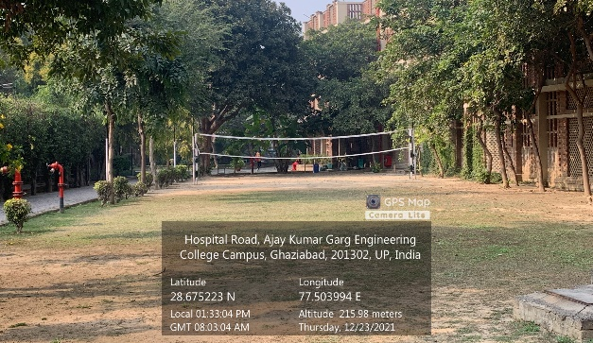

**VOLLEYBALL COURT**

**(GIRLS HOSTEL)**

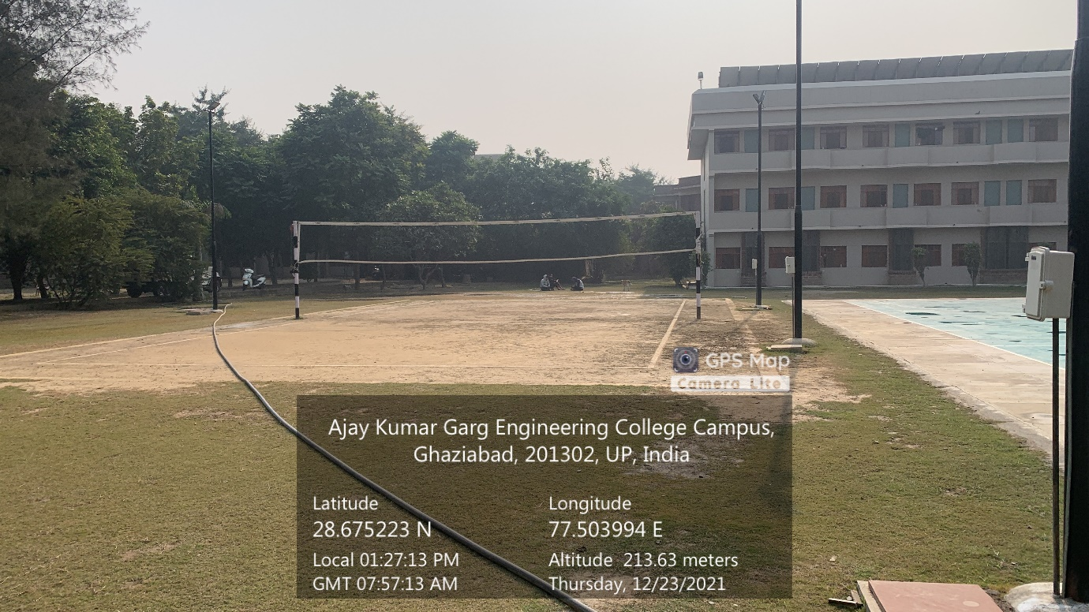

**VOLLEYBALL COURT**

**(BOYS HOSTEL)**

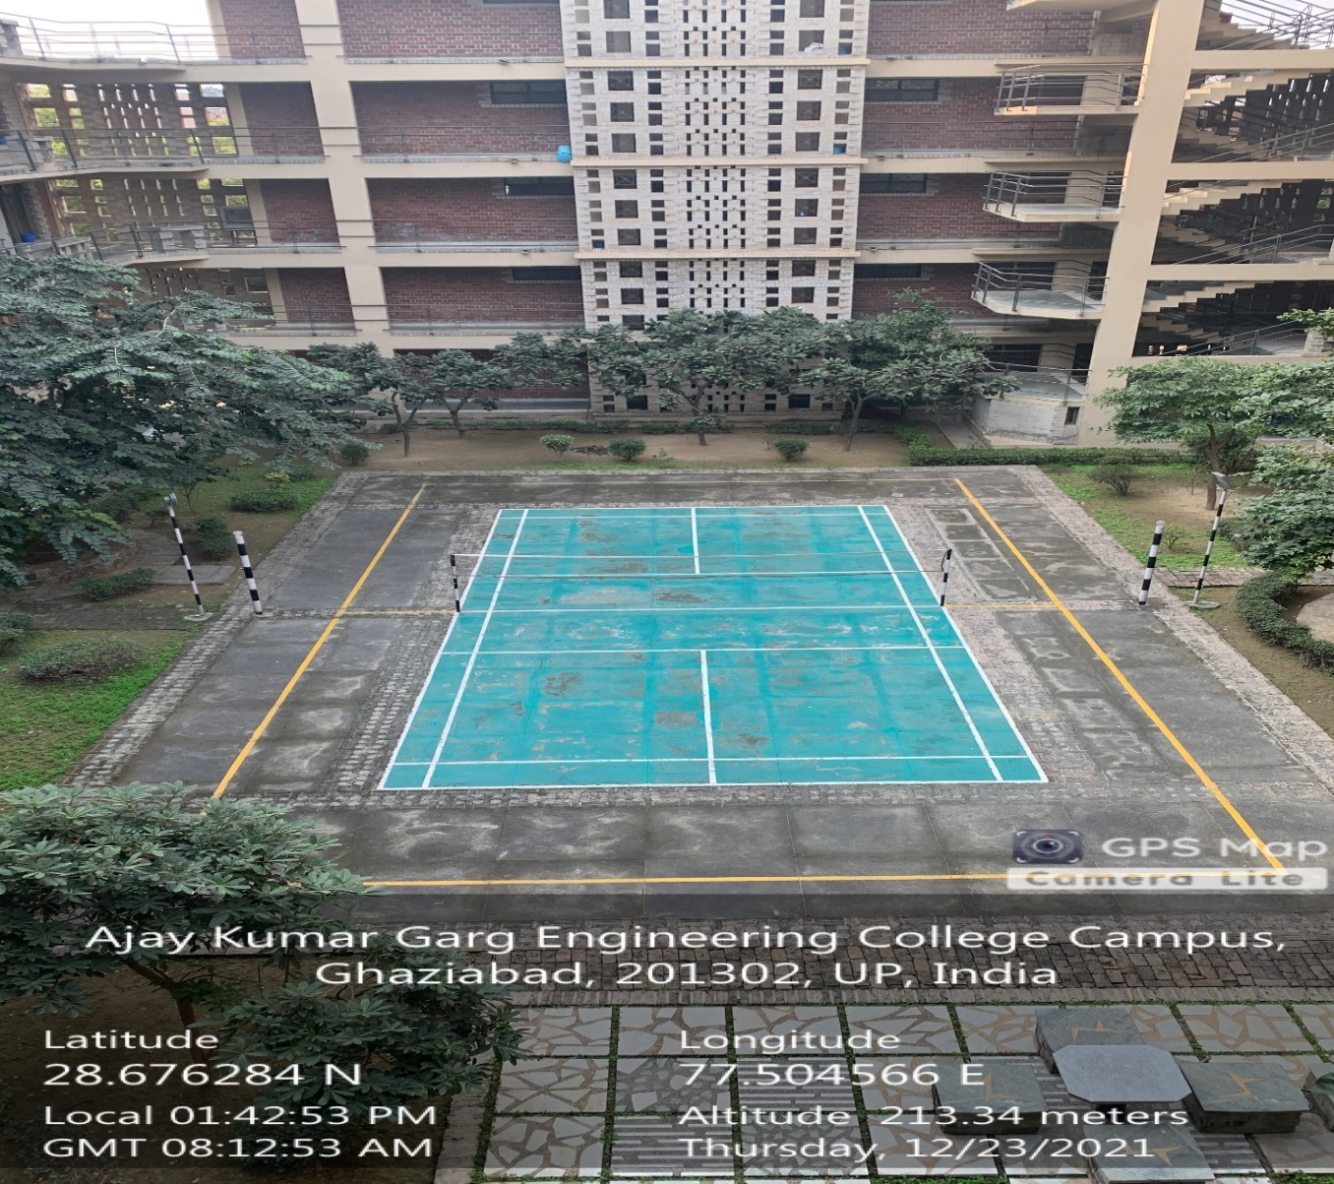

**BADMINTON COURT-1**

**(GIRLS HOSTEL)**

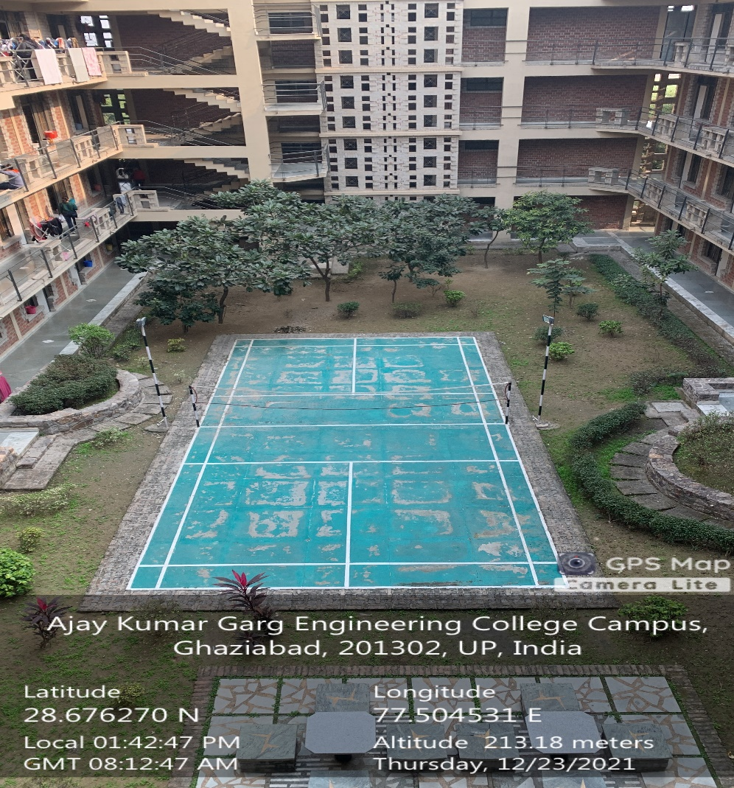

**BADMINTON COURT-2**

**(GIRLS HOSTEL)**

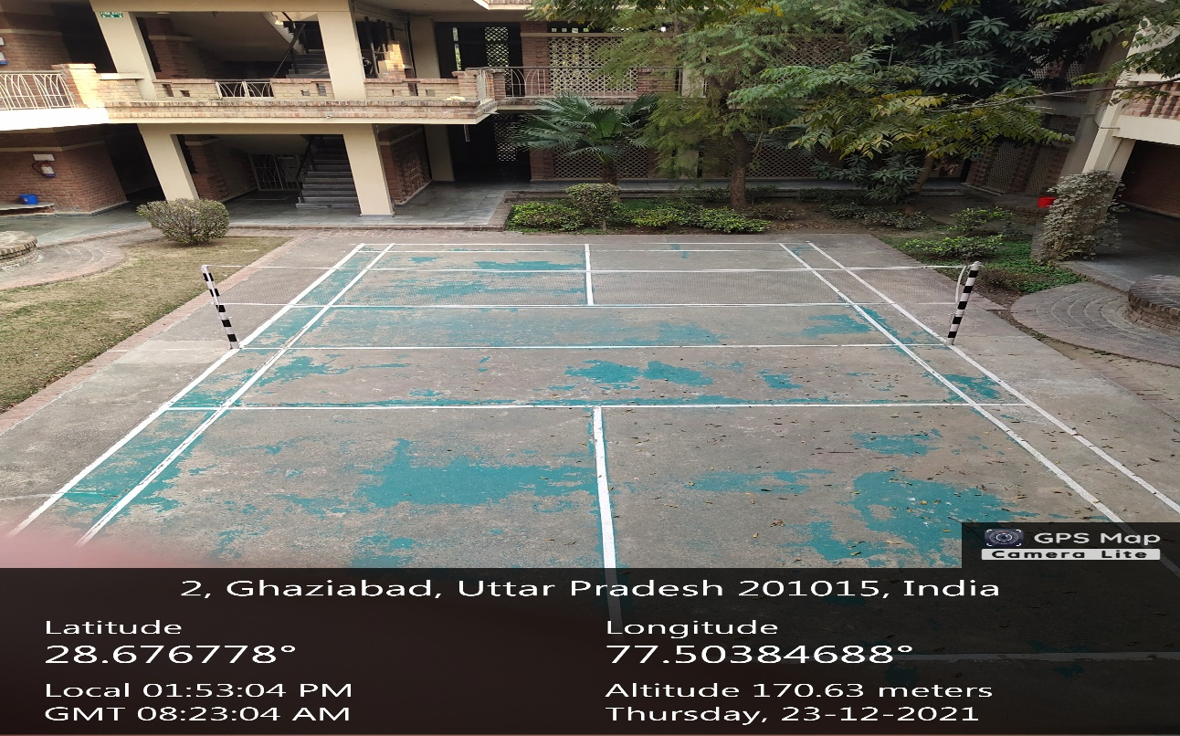**BADMINTON COURT-3**

**(GIRLS HOSTEL)**

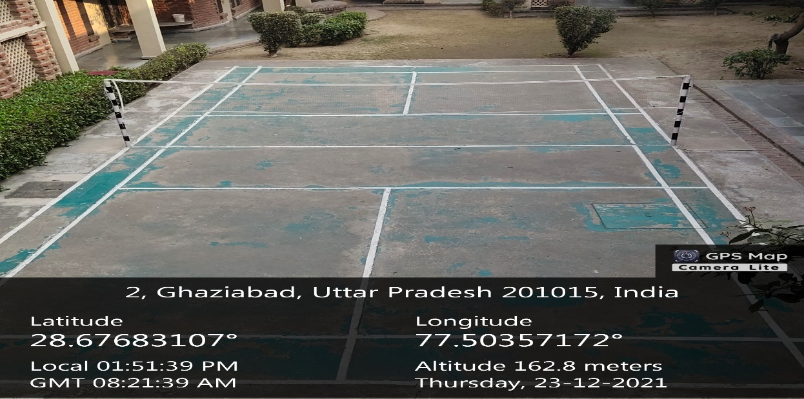

**BADMINTON COURT-4**

**(GIRLS HOSTEL)**

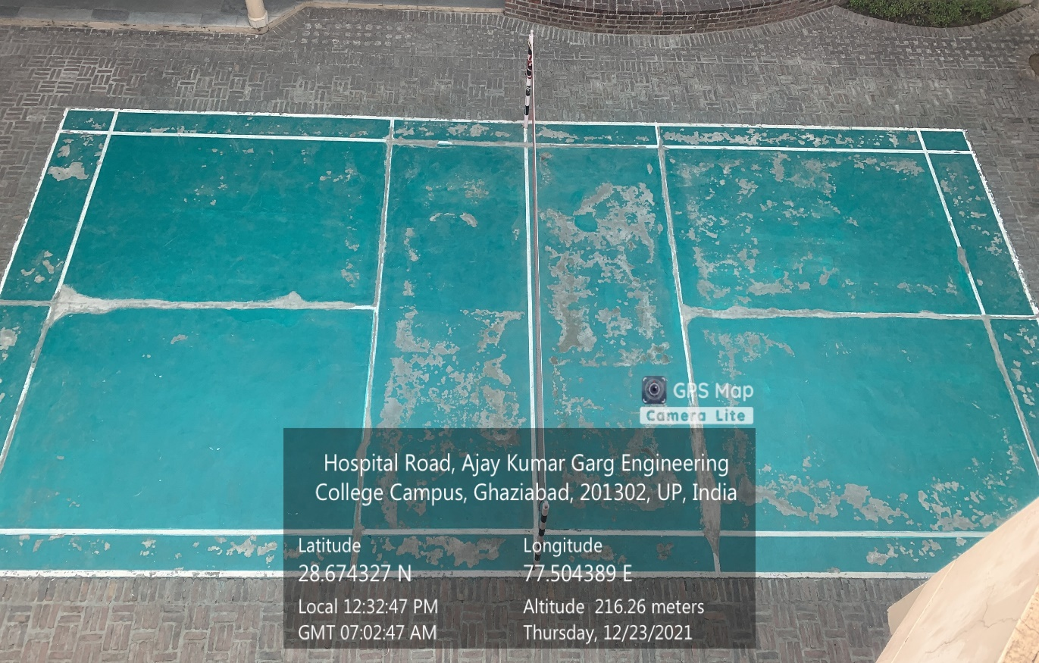

**BADMINTON COURT-1**

**(BOYS HOSTEL)**

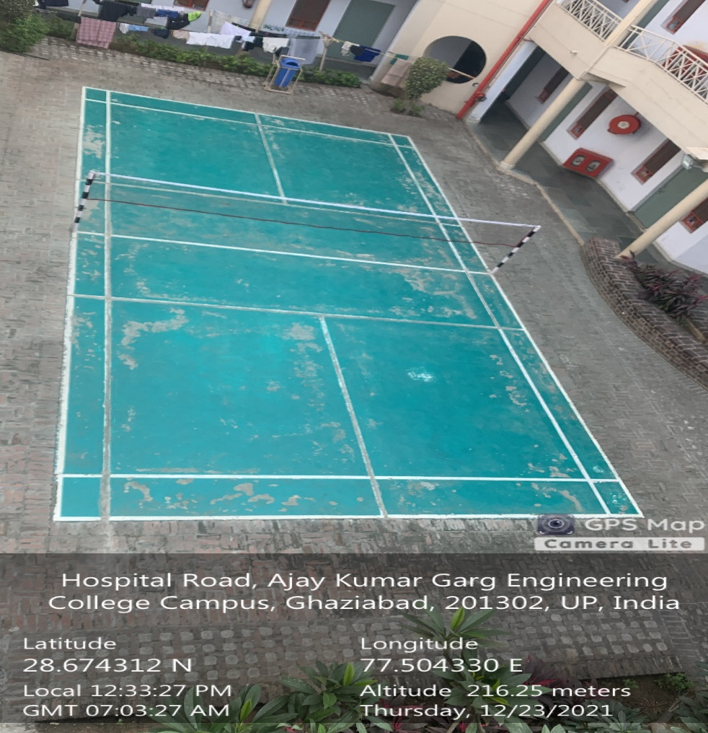

**BADMINTON COURT-2**

**(BOYS HOSTEL)**

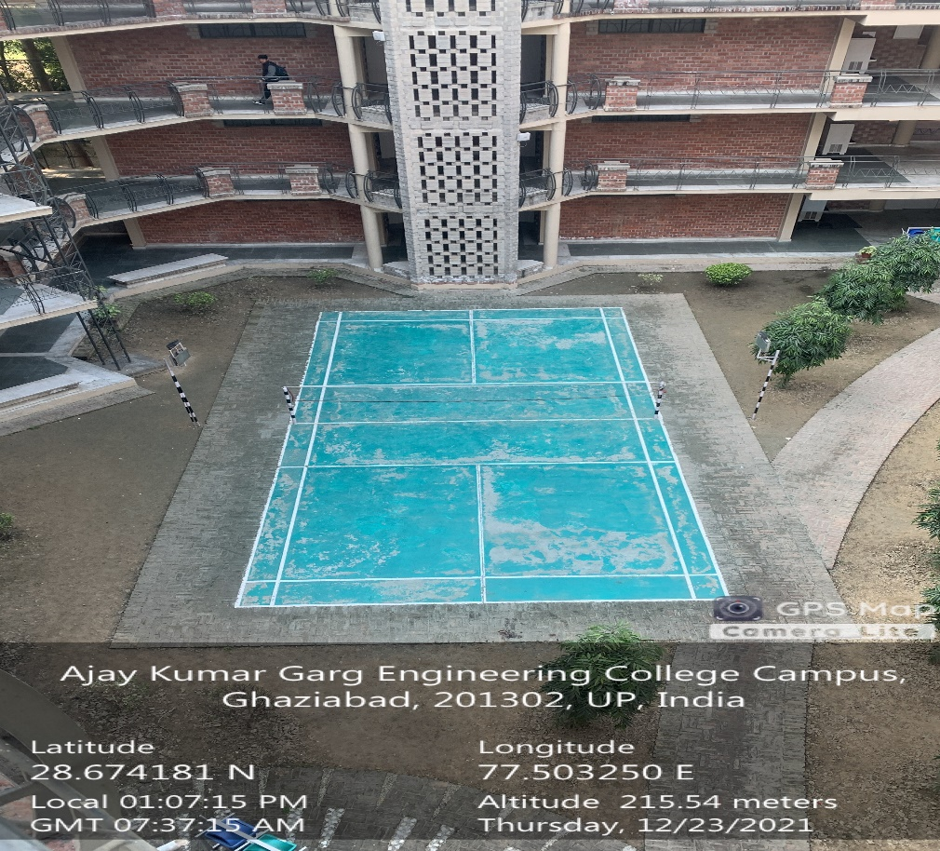

**BADMINTON COURT-3**

**(BOYS HOSTEL)**

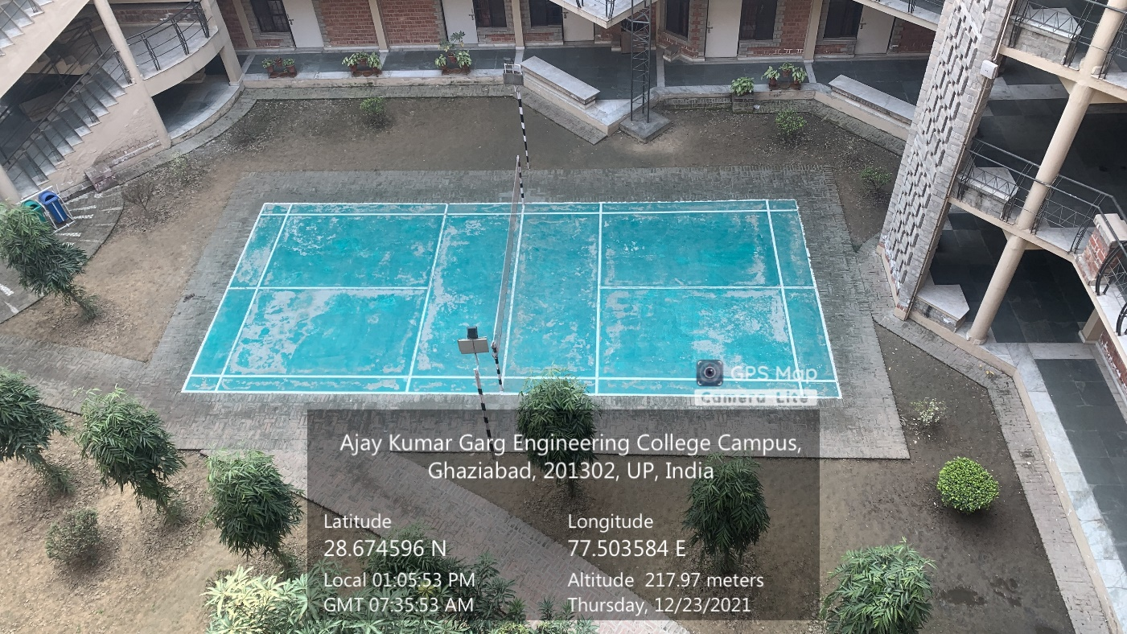

**BADMINTON COURT-4**

**(BOYS HOSTEL)**

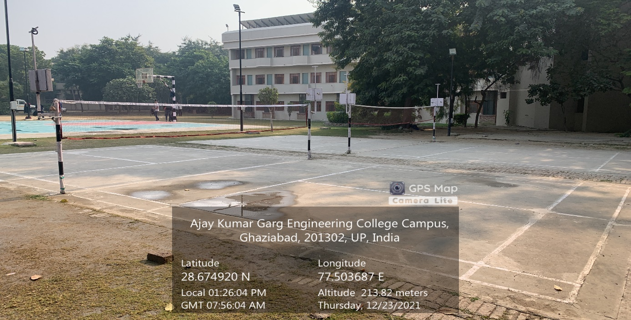

**BADMINTON COURT-5&6**

**(BOYS HOSTEL)**

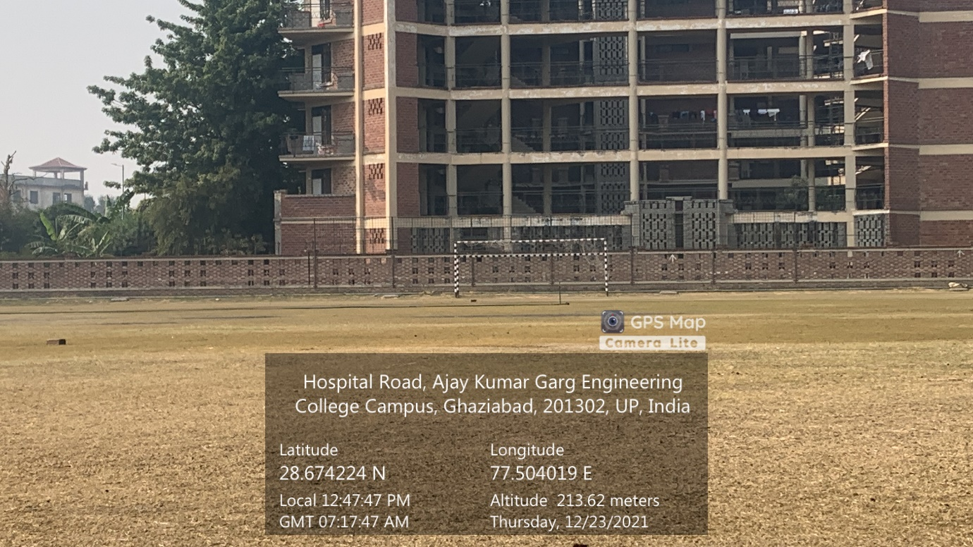

**FOOTBALL GROUND**

**(BOYS)**

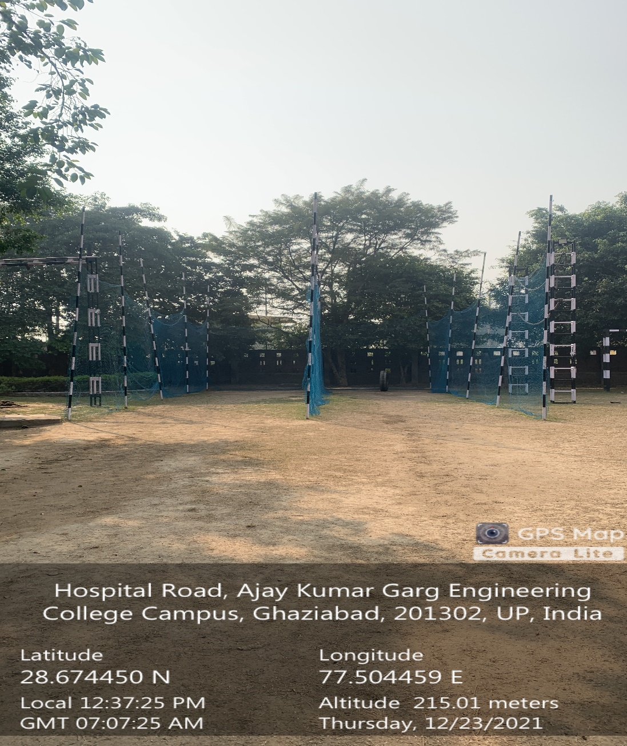

**CRICKET GROUND**

**(BOYS)**

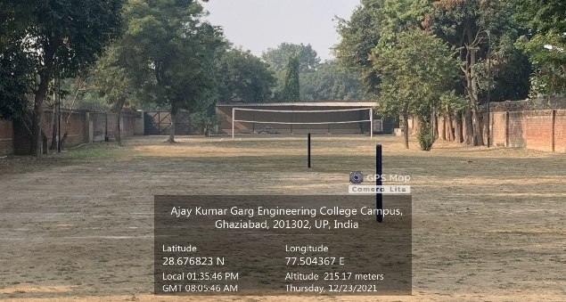

**KHOKHO GROUND**

**(GIRLS HOSTEL)**

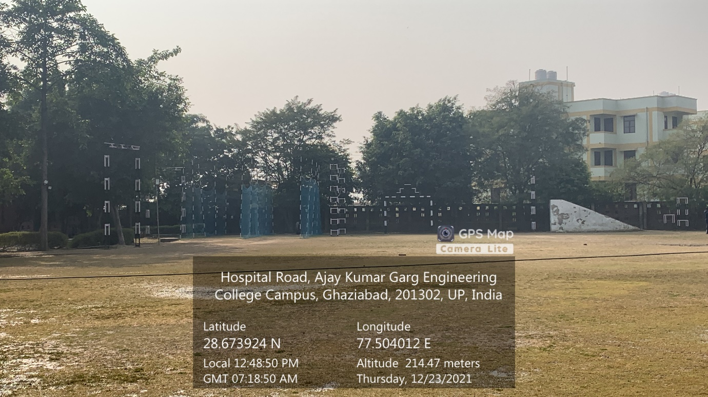

**OBSTACLE COURSE**

**(BOYS & GIRLS)**

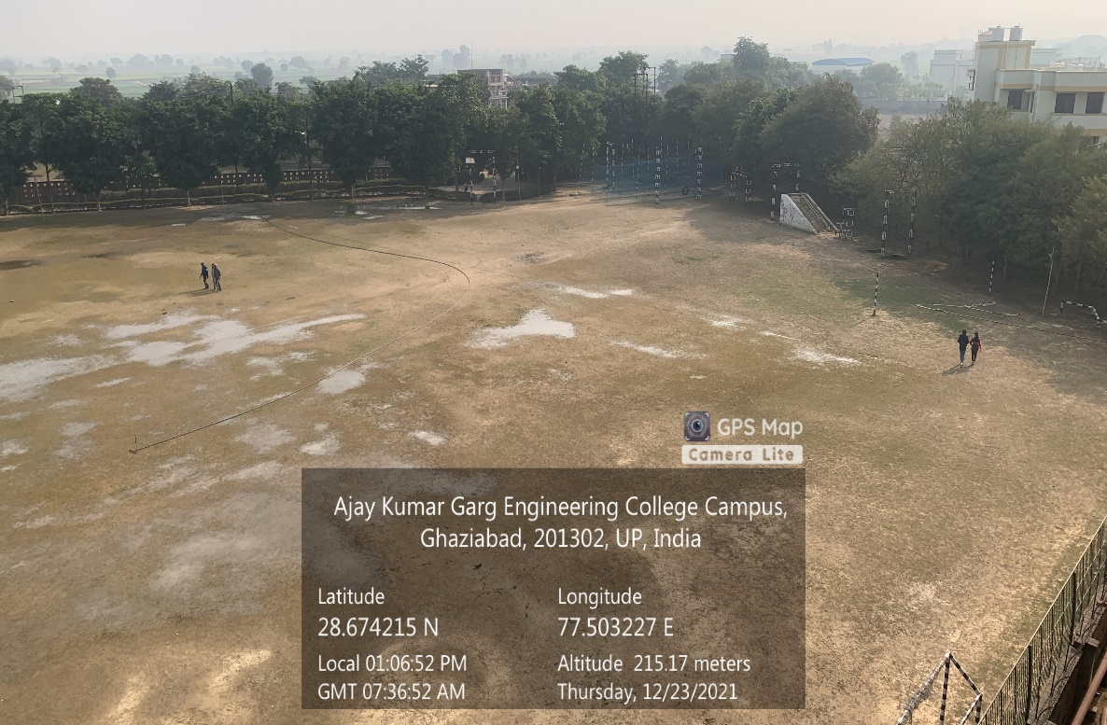

**ATHLETICS GROUND**

**(BOYS &GIRLS)**